HERO STEELS LIMITED
Cold Rolling Steel Plant · Digital Transformation Initiative

MODULE M1 — DATA CAPTURE LAYER
M1-01 · Document 2 of 10
System Architecture
High-level, application, data-flow, integration, user-access & database views, with a concrete recommended technology stack
Document set — M1 Technical Blueprint
Doc | Title
M1-00 | Blueprint Overview & Index
M1-01 | System Architecture
M1-02 | Process-Wise Data Capture Design
M1-03 | UX Design & Operator Workflow
M1-04 | Data Model & Database Design
M1-05 | Role-Based Access Control & Security
M1-06 | Planning Integration & Export
M1-07 | Validation Framework
M1-08 | Audit Trail & Compliance
M1-09 | Reporting & Monitoring
Prepared for Z Company · Role: Manufacturing Digital Transformation Consultant / Industrial Software Architect
Version 1.0 · 30 May 2026 · Confidential

Contents

1. Architecture Overview
M1 is a layered, service-oriented system that runs on the plant network and is reachable from every shop-floor device. The architecture is deliberately conservative: proven components, offline tolerance, clear separation of concerns, and stable contracts at every boundary so later modules attach without disturbing capture. Six views describe it — high-level, application, data flow, integration, user access, and database — followed by the recommended technology stack and deployment topology.
Driver | Architectural response
Shop floor must keep working if the network blips | Offline-first PWA with a local queue; line edge cache; sync on reconnect
Entry must be fast under production pressure | Thin capture API, optimistic UI, server-side validation that returns in <300 ms
Data must be trustworthy and traceable | Single coil spine, server-enforced validation, immutable audit trail
Other modules will consume this data | Versioned REST APIs + domain events + read replica; no direct table access
Plant IT favours supportable, common technology | PostgreSQL, containerised services, standard OIDC SSO, SAP via OData/RFC

2. High-Level Architecture
Six horizontal layers, with security, RBAC, audit and observability as cross-cutting concerns that touch every layer. Devices talk only to the application layer; the application layer talks only to the API layer; persistence, integration and analytics sit behind the services. This strict layering is what keeps the system modular.
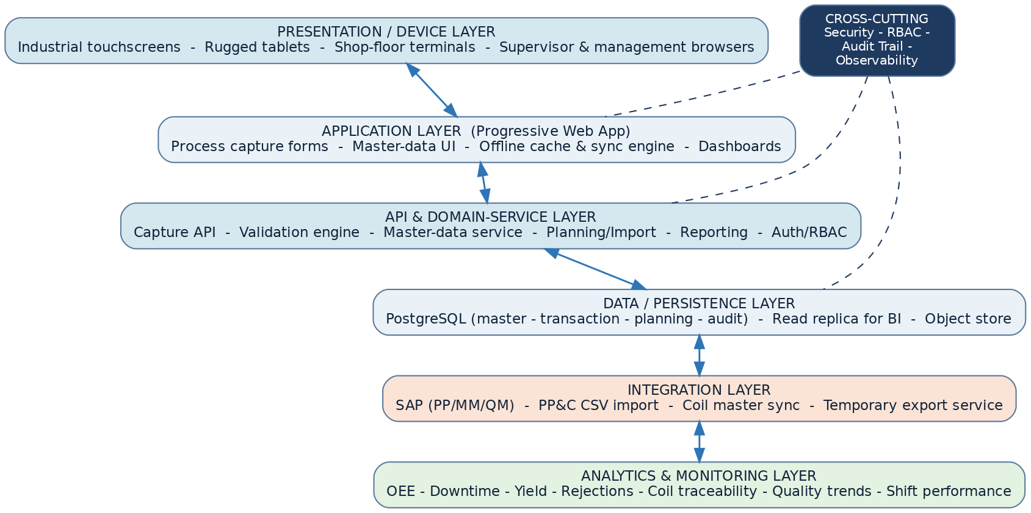
Figure. M1 high-level layered architecture
Layer | Responsibility
Presentation / Device | Industrial touchscreens, rugged tablets and browsers; renders forms and dashboards
Application (PWA) | Capture forms, master-data pickers, offline cache & sync engine, operator dashboard
API & Domain Services | Capture, validation, master-data, planning/import, reporting, auth/RBAC, export
Data / Persistence | PostgreSQL OLTP, BI read replica, object store for attachments/exports
Integration | SAP (PP/MM/QM), PP&C CSV import, coil-master sync, temporary export
Analytics & Monitoring | OEE, downtime, yield, rejections, traceability, quality trends, shift performance

3. Application Architecture
The client is a single Progressive Web App (PWA) installed to the device home screen. It is composed of an app shell plus ten interchangeable process-form modules that all reuse the same shared components (header block, master-data pickers, stoppage/defect/crew sub-forms). An offline cache (IndexedDB) and a sync engine make capture resilient to network loss. The backend is a set of focused services behind one API gateway.
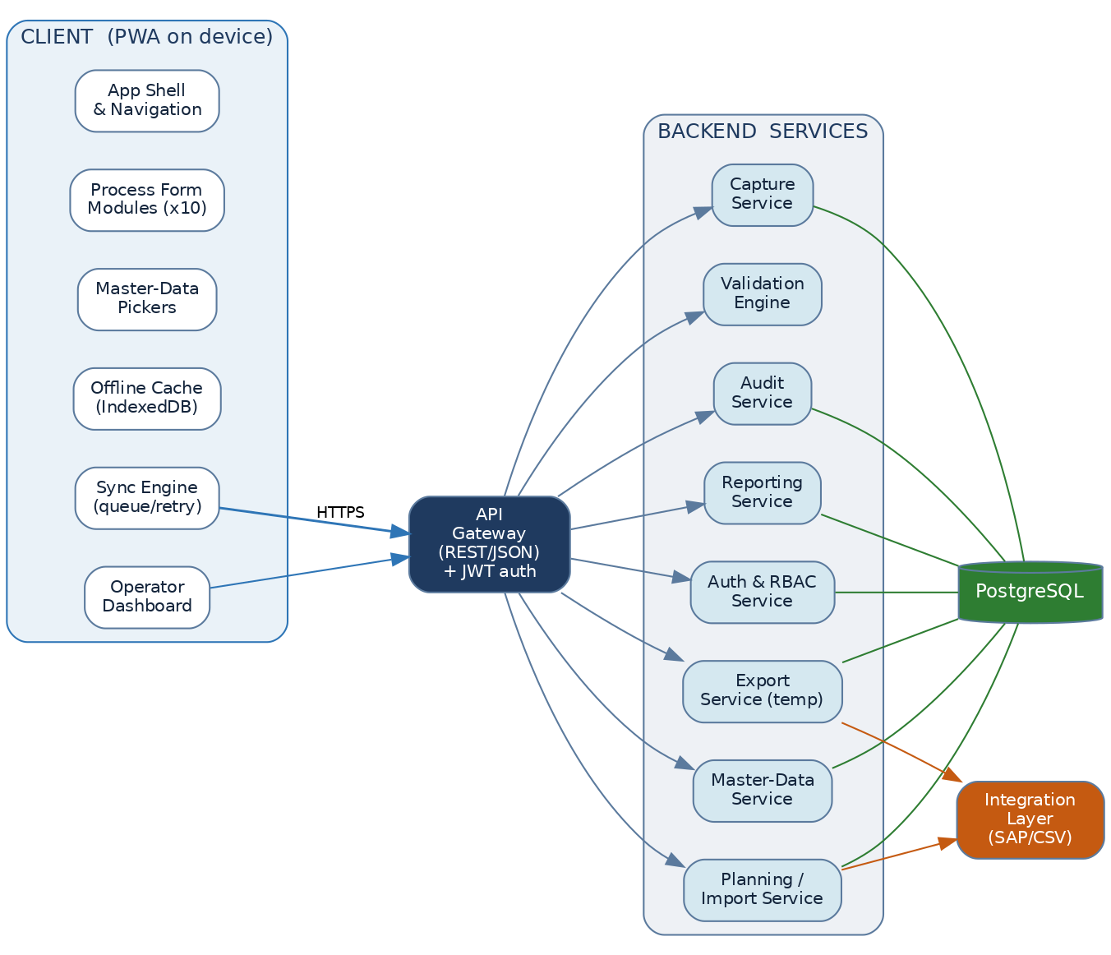
Figure. Application components — client modules, API gateway, backend services

3.1 Client composition
- App shell & navigation — login, line/shift context, routing; loads instantly from cache.
- Process form modules (×10) — one per process; each is just its process-specific section plus the shared blocks.
- Master-data pickers — customer, grade, defect, stoppage, operator; cached locally and searchable offline.
- Offline cache (IndexedDB) — the active shift's plan, coils and masters are pre-loaded at shift start.
- Sync engine — queues entries, retries on reconnect, resolves conflicts by last-writer-with-audit.
- Operator dashboard — target vs produced, open coils, running stoppage, shift progress.

3.2 Backend services
Services are independently deployable but share one database. Splitting them by responsibility keeps each small and lets reporting or integration scale separately from capture.
Service | Responsibility
Capture | Create/update shift logs and process entries; orchestrates validation; emits events
Validation engine | Stateless rule evaluation (range, mandatory, dependency, duplicate, spec) — shared by client & server
Master-data | Serves and manages customer, grade, defect, stoppage, operator, furnace masters
Planning / Import | CSV import pipeline and SAP sync; populates plan & coil master
Reporting | Reads the replica; serves dashboards and KPI aggregates
Auth & RBAC | OIDC token validation, role & line-scope resolution, policy enforcement
Audit | Writes the immutable audit log; manages change requests
Export (temporary) | Generates filtered CSV/XLSX extracts; logs every export

4. Data Flow Architecture
Data flows along the physical material path. Planning seeds the coil master; each process reads the coil's current state, captures its shift data, and writes the coil forward with refined dimensions and properties. Annealing introduces a charge/base grouping over coils. CRS may set a For-CTL routing flag. Every capture also feeds the reporting/traceability layer.
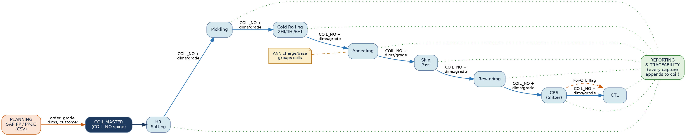
Figure. Material-and-data flow with the COIL_NO traceability spine
At each handoff the coil identity, grade and current dimensions/weight carry forward; thickness reduces through rolling, and mechanical properties are set at annealing and verified at CRS. Because all processes write to one coil record, a coil's full genealogy is reconstructable at any point — the basis of the traceability analytics in M1-09.

5. Integration Architecture
M1 sources planning and master data from SAP and the PP&C scheduling spreadsheets, and (interim) exports actuals back out. An integration layer isolates M1 from source-system specifics: connectors fetch, a mapping/transform step normalises to canonical fields and units, a staging area reconciles, and only validated records are upserted into M1.
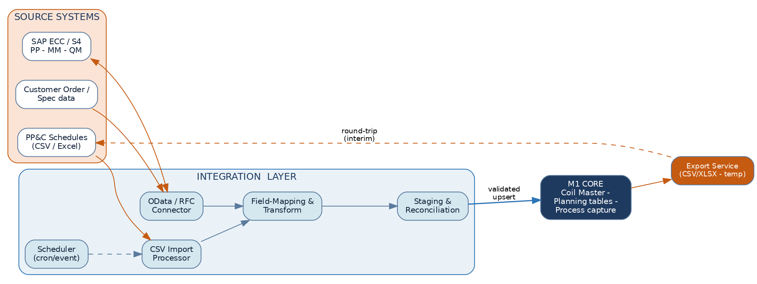
Figure. Integration layer between source systems and the M1 core
- Inbound, Phase 1 (CSV): PP&C schedule files are dropped/scheduled, validated, staged and loaded into plan & coil master.
- Inbound, Phase 2 (SAP): OData/RFC connectors pull production orders, customer/grade master and QM specs on a schedule or event.
- Outbound (interim): the temporary export service produces CSV/XLSX for existing reports until write-back/modules are live.
- Future: actuals write-back to SAP PP and event publication to downstream modules (M2–M7).

6. User Access Architecture
Authentication is delegated to the plant identity provider via OIDC SSO (with a badge + PIN fallback for shared shop-floor terminals). The API gateway validates the token; the RBAC policy engine resolves the user's role and the lines they may access; and data access is filtered at the row level by line and role. An operator physically cannot see another line's data — the filter is applied server-side, not in the UI.
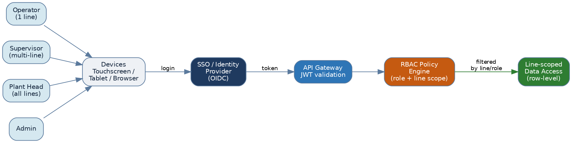
Figure. Authentication, RBAC and line-scoped data access
Role definitions and the full permission matrix are in M1-05. The key architectural point is that line-scoping is enforced in the data layer (row-level), so every API — capture, reporting, export — inherits the same access rules automatically.

7. Database Architecture
A single PostgreSQL primary handles OLTP capture, organised into logical schemas (master, coil, txn, planning, security, audit). A streaming read replica serves reporting and BI so analytics never competes with capture for resources. An object store holds attachments and generated exports; backups with point-in-time recovery and a DR standby protect the record.
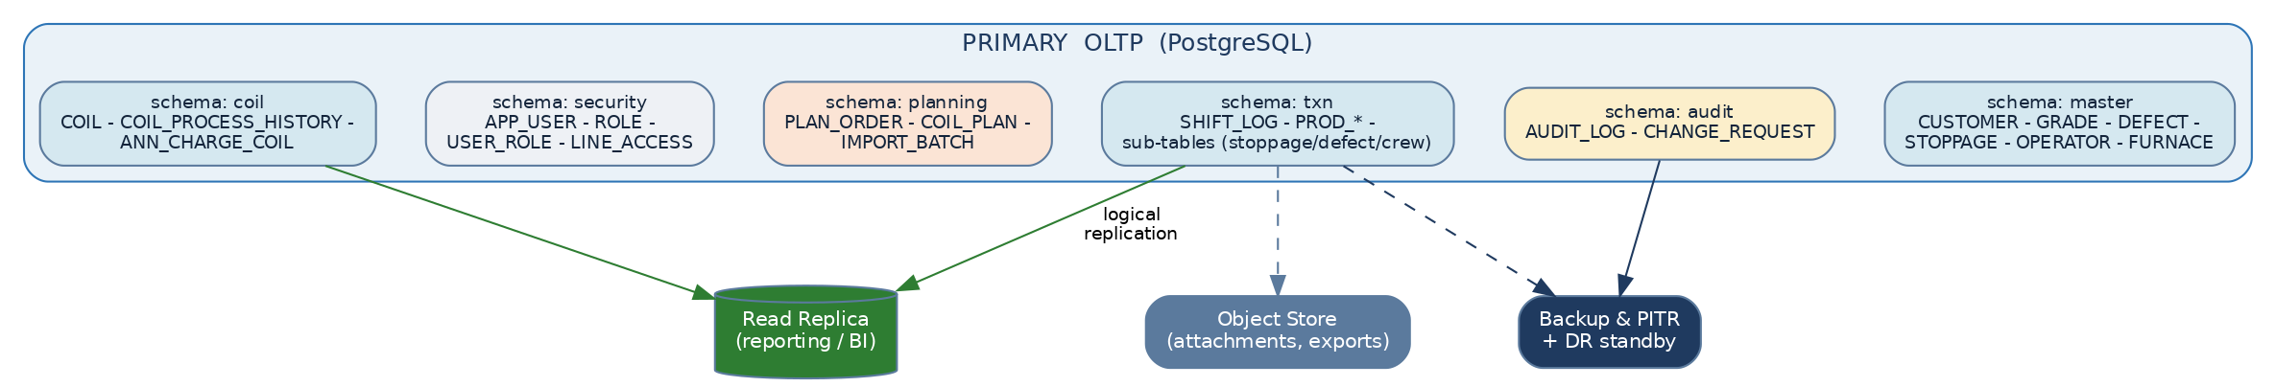
Figure. Database logical architecture and supporting stores
The schema separation mirrors the modularity strategy: masters are shared and slowly-changing; transaction tables are append-heavy and partitioned by date; audit is write-once. Full table structures, keys and the runnable DDL are in M1-04 and the companion M1_schema.sql.

8. Recommended Technology Stack
The stack below is chosen for shop-floor reliability, plant-IT supportability, and a clean path to the later modules. It favours mature, widely-supported components over novelty.
Layer | Recommendation | Why
Client | React + TypeScript PWA (offline-first, service worker, IndexedDB) | One codebase for touchscreen/tablet/browser; installable; works through network blips
UI controls | Large-target component library; on-screen numeric keypad; virtualised pickers | Built for gloved, standing operators (see M1-03)
API | REST/JSON over HTTPS behind an API gateway; OpenAPI-documented | Simple, cacheable, easy for later modules to consume; versioned contracts
Services | Containerised (Docker) Node.js/TypeScript or Java/Spring Boot services | Independently deployable; common skills in plant IT
Validation | Shared rule library packaged for both client and server | Identical rules everywhere; no client/server drift (M1-07)
Database | PostgreSQL 15+ (primary + streaming read replica), date-partitioned txn tables | ACID, JSONB for flexible attributes, robust replication, no licence cost
Auth | OIDC SSO (Keycloak / Azure AD / plant IdP); badge+PIN fallback | Plant-standard identity; MFA where required; shared-terminal friendly
Integration | Scheduler + CSV pipeline now; SAP OData/RFC connector + middleware later | Phased: value from CSV immediately, SAP when scope is signed off (M1-06)
Object store | S3-compatible store (on-prem MinIO or cloud) | Attachments and exports off the OLTP database
Observability | Central logs + metrics + uptime alerts; structured audit | Operability and the compliance trail (M1-08)
Deployment | On-prem plant data centre (latency, autonomy) or private cloud | Capture must survive WAN loss; on-prem keeps the floor independent

9. Deployment & Topology
Devices on each line reach an app-server cluster (load-balanced, 2+ nodes) in the plant data centre. A line edge cache buffers entries during brief network loss. The database runs primary + replica; an integration server brokers SAP/PP&C; a BI server reads the replica; backups stream to a DR site.
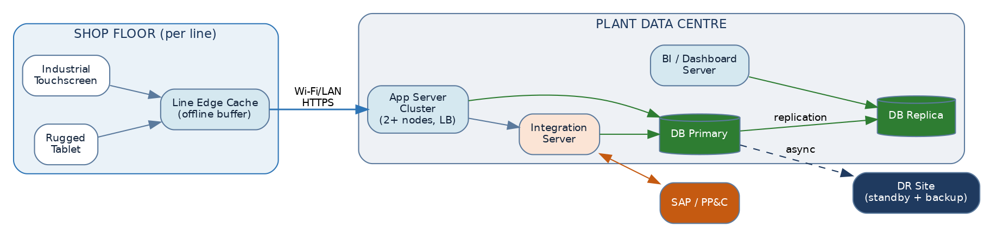
Figure. Deployment topology — shop floor, plant data centre, SAP and DR

9.1 Indicative sizing (pilot → plant-wide)
Dimension | Pilot (1–2 lines) | Plant-wide (10 processes)
Concurrent devices | 5–15 | 40–80
Coil entries / day | 300–800 | 3,000–6,000
App nodes | 2 (HA pair) | 3–4 behind LB
DB | 1 primary + 1 replica | 1 primary + 1–2 replicas, partitioned
Storage growth | ~1–2 GB / month | ~10–20 GB / month (excl. attachments)

10. Non-Functional Requirements
Quality | Target / approach
Availability | ≥ 99.5% on the floor; offline capture means brief outages don't stop work
Performance | Form open < 1 s; validate+save < 300 ms; dashboard < 2 s
Scalability | Stateless services scale horizontally; replica absorbs reporting load; txn tables partitioned by date
Resilience | Edge cache + client queue tolerate network loss; DB failover to replica; DR standby
Security | OIDC SSO, row-level line scoping, TLS everywhere, least-privilege service accounts (M1-05)
Auditability | Immutable audit log on every change; correction via approval workflow (M1-08)
Modularity | Versioned APIs + events + read replica; schema separation; one process module per line
Maintainability | Containerised, OpenAPI-documented, shared validation library, infrastructure-as-code

